Minutes of General Assembly SCOPE – 30th September 2026, 6:15 pm, ANT5033

Current members:

Alicia Baudois, Alicia Saner, Amélie Dauban, Bianca Boscolo detto Sassariolo, Cheyenne Wildt, Cindy Zhang (Webmaster), Hannah Maxwell, Katerina Lo Presti, Laura Maric, Leah Didisheim (President), Lina Rosinander, Lisa Ziegert (Treasurer until this AG), Malory Goy (Vice-president), Martina Quadroni, Maxime Jaquet, Maxime Regamey, Radina Vladkova, Shymene Alhauari, Thaïs Zanghi, Tonia Ramogida, Valentina Dallinger, Valeriia Volkhonska (Secretary)

OUT: Alicia Saner, Katerina Lo Presti, Martina Quadroni, Radina Vladkova, Thaïs Zanghi, Tonia Ramogida
IN: Charlotte Marton, Julia Harmsen (Treasurer from this AG)

Present:
Alicia Baudois, Amélie Dauban, Charlotte Marton, Cindy Zhang, Julia Harmsen, Laura Maric, Leah Didisheim, Lina Rosinander, Lisa Ziegert, Malory Goy, Valeriia Volkhonska

Absent: Alicia Saner, Bianca Boscolo detto Sassariolo, Cheyenne Wildt, Hannah Maxwell, Katerina Lo Presti, Martina Quadroni, Maxime Jaquet, Maxime Regamey, Radina Vladkova, Shymene Alhauari, Thaïs Zanghi, Tonia Ramogida, Valentina Dallinger

1. Welcome & Introductions
Leah welcomes the assembly at 18:24. She is conducting the AG as current President and therefore is not counted in the votes.

2. Accepting previous minutes and the current agenda

a. PV
- 10 for (out of 10)
- 0 against
- 0 abstention(s)

b. ODJ
- 10 for (out of 10)
- 0 against
- 0 abstention(s)

3. Elections

a. President
3.a.i. Current: Leah Didisheim
(going for re-election)
3.a.i.1. 10 for (out of 10)
3.a.i.2. 0 against
3.a.i.3. 0 abstention(s)

b. Vice-president
3.b.i. Current: Malory Goy
(going for re-election)
3.b.i.1. 10 for (out of 10)
3.b.i.2. 0 against
3.b.i.3. 0 abstention(s)

c. Secretary
3.c.i. Current: Valeriia Volkhonska
(going for re-election)
3.c.i.1. 10 for (out of 10)
3.c.i.2. 0 against
3.c.i.3. 0 abstention(s)

d. Webmaster
3.d.i. Current: Cindy Zhang
(going for re-election)
3.d.i.1. 10 for (out of 10)
3.d.i.2. 0 against
3.d.i.3. 0 abstention(s)

e. Treasurer
3.e.i. Current: Lisa Ziegert
(NOT going for re-election)
e.ii. Candidate: Julia Harmsen
e.ii.1. 10 for (out of 10)
e.ii.2. 0 against
e.ii.3. 0 abstention(s)

4. Budget & Accounting
a. Spring 2026 Account Summary
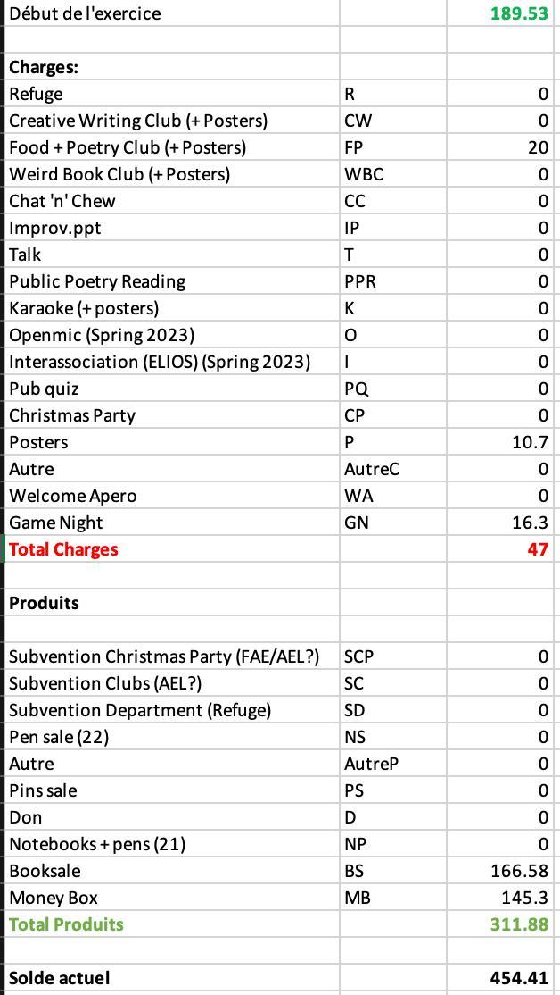
Lisa presents the account summary for the previous semester. SCOPE spent relatively little money during the semester, partly because not all members requested reimbursement for their expenses. The association also received more than CHF 150 from the book sale. Lina had to leave at 18:41; from that moment, there were 9 people accepting the budget.
2.a.i.1. 9 for (out of 9)
2.a.i.2. 0 against
2.a.i.3. 0 abstention(s)

5. Previous events
- Team Building (Valeriia Volkhonska)
The previous Team Building took place during the summer at Plage de Vidy, on the 8th of July. Members spent several hours together, played games, ate together and attempted to barbecue. The organization was more complicated than usual because it took place later in the year and some organizers were unavailable. Valeriia, who organized the event, had to leave early because of an emergency involving her pup.
- Improv.ppt (Lina Rosinander and Radina Vladkova)
The previous Improv.ppt took place on the 22nd of April and did not attract many participants, with approximately three or four people attending. Lina noted that the unused PowerPoint presentations can nevertheless be reused for a future edition.
It is suggested that publicity should be sent out earlier so that students can reserve the date in advance. The timing of SCOPE’s events should also take other university events into account, as simultaneous events can negatively affect attendance.
The format of Improv.ppt is explained for newer members: participants submit short PowerPoint presentations, which are then presented by other participants without them knowing the content in advance.
- Talk (Laura Maric)
The Talk happened on 28th of April, at 6:15 pm, so students whose classes finished at 6 had time to join. Laura did a good job coordinating this event. A post-doc researcher, Patrizia Zanella, talked about “Reclaiming Indigenous Languages through Indigenous Literatures”. It was a great success, and a lot of people attended.
- Pub Quiz (Malory Goy and Alicia Baudois)
The Pub Quiz is a recurring SCOPE event, and this time it was held on the 30th of April at the QWERTZ bar (Rue de la Grotte 3, 1003, Lausanne). The venue is considered suitable because the owner is welcoming towards SCOPE and does not charge the association for using the space. The committee also discusses the importance of booking the venue well in advance.
- Game Night (Amélie Dauban)
The event was considered great fun and required relatively little additional organization from SCOPE. It occurred on the 29th of April at the CAP and was co-organized alongside several associations (Helios, Paragone, No Cap, Ciné-club, Stu.de).

6. Clubs
- Creative Writing Club (Current organizers: Leah Didisheim)
Leah explains that she has organized the club for several years but does not want to continue organizing it alone. Given that it is her last year at UNIL, she would like another member to co-organize it and eventually take over.
Charlotte and Laura express interest in helping with the club. The possibility of organizing it as a group of three during the current semester is discussed to facilitate a future transition. The club will only continue if members are willing to organize it.
- Food + Poetry Club (Current organizers: Lisa Ziegert)
The format consists of food and drinks combined with the reading or sharing of poetry and other literary texts. Lisa says that the previous semester's attendance was very low, but Valeriia brought a poetry card game to one of the sessions, so it was still fun. Lisa thinks of merging it with the Chat’n’Chew format (once a week during the semester), and she would like to open it up a bit more and turn it into a “food + any kind of writing” club, so people could bring in a quote, poem, or text in the general sense.
Cindy and Malory propose their help with the club for this semester. Leah discusses improving visibility by advertising the clubs more actively, including through the SCOPE group chat and potentially by coordinating publicity with other associations.
- Organization of clubs
The committee discusses organizing the clubs on a regular basis and alternating them, so that there is a club activity on a consistent day while the Creative Writing Club and Food & Poetry Club alternate from week to week.
Members are also reminded that existing clubs can be changed or discontinued and that new clubs can be created if members are interested in organizing them.

7. Money-Making
- Book sale
We still have books in the locker room downstairs. The committee would like to continue organizing book sales until the remaining stock has been sold. Several possible approaches are discussed, including mystery-wrapped books. We aim to do it again next semester.
Valeriia volunteers to organize the next book sale and indicates that she now has more experience with its organization and promotion. Other members will be asked to help with the practical aspects, particularly on the days of the sale.
- Notebook sale
We still have notebooks available. These can continue to be sold during events and other appropriate occasions.
- Pen sale
Pens are also still available. These can continue to be sold during events and other appropriate occasions.

8. Upcoming events
- Asso’Découverte (Laura Maric, Lina Rosinander & Leah Didisheim)
SCOPE is participating in an event organized by FAE with other associations for new students. The event is taking place the following Wednesday, the 7th of October. Laura, Lina and Leah are involved in taking care of SCOPE's participation. The purpose is to introduce SCOPE to new students through games and an activity involving songs. SCOPE plans to use famous songs with French lyrics, asking participants to translate or identify the songs in English. The event begins at 6 pm, with preparation taking place beforehand. SCOPE members will also be able to participate in the food and other activities organized as part of the event.
- Talk
A SCOPE talk is unlikely to take place during the current semester because the organization has not started early enough. The committee discusses possible staff members who could be invited for a talk during the following semester. Laura volunteered to organize the next talk. She suggests asking Marie Emilie Waltz to be the next speaker, and the committee agrees that she can be approached regarding a talk for the following semester.
- Game Night
A Game Night is discussed as a possible event for the following semester. Alicia will represent SCOPE in the inter-association organization of the event. Further details will be communicated once they are available.
- Pub Quiz
The Pub Quiz is expected to take place during the following semester. Malory and Alicia agree to organize it.
- Improv.ppt
The possibility of organizing another Improv.ppt is discussed. Since previous editions have had low attendance, the committee is considering whether to continue the event. Existing PowerPoint presentations can still be reused. Members are invited to organize the event during the next semester if they are interested but it is not taking place this semester.
- Christmas Party
The Christmas Party will take place on the 9th of December. Leah and Malory agree to coordinate the organization. Additional members will be recruited through the SCOPE group chat to help with the preparation and the day of the event.
The possibility of preparing food together on the day before the party is discussed as a way of reducing costs. Leah offers the option of using her kitchen for the preparation.
- Other events
Members are reminded that they can propose and organize additional events during the semester. If an organizer realises that they no longer have time to prepare an event, they are encouraged to inform the group so that another member can take over.

9. Team Building
Leah agrees to organize the next Team Building and offers to host it at her apartment if appropriate. She expects this to be the last Team Building she organizes. A form will be sent to the group to determine availability and organize the event.

10. Budget & Accounting
a. Autumn 2026 Budget Projection
Lisa presents the projected budget for the current semester. She reminds everyone that if people need more money, they have to reach out to Lisa before spending it, take a picture of the receipt, and send it to her so that it can be reimbursed. The proposed allocations include:
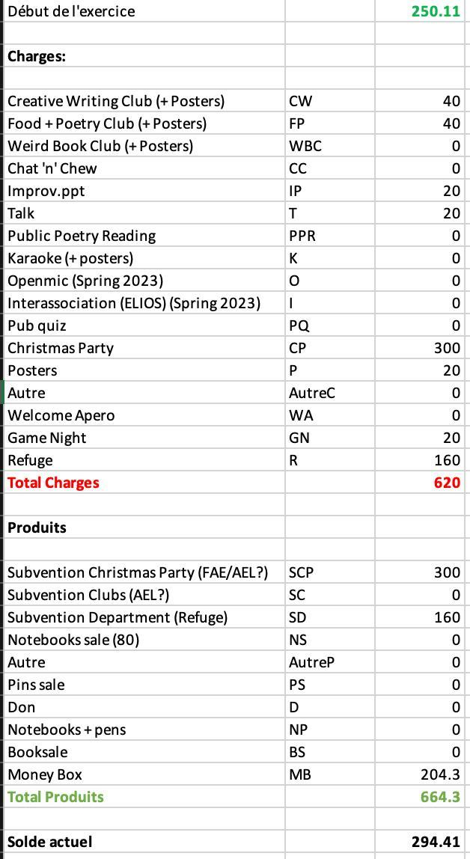
The Christmas Party budget is based on the amount spent on the previous year's event. The new Treasurer, Julia Harmsen, should also look into obtaining a subsidy for the event.

8.a.i. 9 for (out of 9)
8.a.ii. 0 against
8.a.iii. 0 abstention(s)

11. Other
Leah raises a concern about communication and participation within SCOPE during the previous semester. She explains that messages sent to the group chat and committee group chats sometimes received no response, including messages concerning possible activities and events. She stresses that members do not have to participate in every activity, but asks members to respond to messages when possible so that organizers know whether there is interest in an activity and whether they can proceed. She also expresses concern about the continuity of SCOPE once she is no longer President, given that fewer members have recently been taking initiative to organize activities. The discussion emphasizes that SCOPE is intended to remain a low-commitment association, but that some degree of participation and communication is necessary for activities to continue.
Charlotte questions the possibility of adding MUSE as a subcommission of SCOPE. The discussion considers the relationship between SCOPE and MUSE, noting that there has historically been considerable overlap between the two, particularly through the Creative Writing Club and organizers. The possibility of closer integration or collaboration between SCOPE and MUSE is raised, partly in relation to funding and subsidies. The SCOPE statutes will be reviewed to determine what forms of collaboration or integration would be possible. No final decision has been taken on the matter.
Leah also mentions that the AEL has created a group chat bringing together the different associations in Lettres to help avoid scheduling conflicts and facilitate collaboration between associations. Valeriia and Leah currently represent SCOPE on this group chat. An inter-association calendar has also been created, allowing associations to add their upcoming events and check existing events when planning new ones. The calendar has been added to the group chat description for easy access and should always be checked when deciding on a date for an event so we can avoid different Lettres events taking place at the same time as much as possible.

Leah closes the assembly at 7.38 pm.

“Current members” is used for internal purposes to refer to individuals who either are or have been students in UNIL’s English Department who wish to participate more closely in the organization of SCOPE events and activities and who the committee communicates with informally. This practice does not seek to come into conflict with Article 3 of SCOPE's statuts, which states that all students regularly enrolled in courses taught by the English section are members. c.F SCOPE’s statuts: 3.1 Est membre d’office, tout-e étudiant-e régulièrement inscrit-e à des enseignements dispensés par la section d’Anglais.

