General Assembly SCOPE – 8th October 2025, 12:30pm, ANT5157

Current members:
Alicia Saner (Secretary), Amélie Dauban (Webmaster), Andreia Abreu Remigio (Vice-President), Bianca Boscolo detto Sassariolo, Cindy Zhang, Hannah Maxwell, Katerina Lo Presti, Katharina Schwarck, Leah Didisheim (President), Lina Rosinander, Lisa Ziegert (Treasurer), Lucrezia Ferraú, Malory Goy, Martina Quadroni, Maxime Regamey, Lex Rodriguez, Réka Gaál, Thaïs Zanghi, Tonia Ramogida, William Flores

OUT: Katharina Schwarck, Lex Rodriguez, Lucrezia Ferraú, Réka Gaál
IN: Alicia Baudois, Cheyenne Wildt, Laura Maric, Maxime Jaquet, Radina Vladkova, Shymene Alhauari, Valeriia Volkhonska

Present:
Alicia Saner, Amélie Dauban, Andreia Abreu Remigio, Bianca Boscolo detto Sassariolo, Cheyenne Wildt, Cindy Zhang, Hannah Maxwell (arrived at 12.45, before voting on Vice-president), Katerina Lo Presti, Laura Maric, Leah Didisheim, Lina Rosinander, Lisa Ziegert, Malory Goy, Shymene Alhauari, William Flores
Absent: Alicia Baudois, Katharina Schwarck, Lucrezia Ferraú, Martina Quadroni, Maxime Jaquet, Maxime Regamey, Lex Rodriguez, Réka Gaál, Thaïs Zanghi, Tonia Ramogida, Radina Vladkova, Valeriia Volkhonska

- Welcome & Introductions
Leah and Andreia welcome the assembly at 12.35.

- Accepting previous minutes and the current agenda
- PV
  - 12 for (out of 13)
  - 0 against
  - 1 abstention(s)
- ODJ
  - 12 for (out of 13)
  - 0 against
  - 1 abstention(s)

- Elections
  - President
    - Current: Leah Didisheim
(going for re-election)
      - 13 for (out of 13)
      - 0 against
      - 0 abstention(s)

Note: Hannah arrives late at 12.45. We are therefore now 14 people to vote (plus SCOPE'S president, Leah, in case of a tie).

  - Vice-president
    - Current: Andreia Abreu Remigio
(NOT going for re-election)
    - Candidate: Malory Goy
      - 14 for (out of 14)
      - 0 against
      - 0 abstention(s)
  - Secretary
    - Current: Alicia Saner
(going for re-election)
      - 13 for (out of 14)
      - 0 against
      - 1 abstention(s)
  - Webmaster
    - Current: Amélie Dauban
(NOT going for re-election)
    - Candidate: Cindy Zhang
      - 13 for (out of 14)
      - 0 against
      - 1 abstention(s)
  - Treasurer
    - Current: Lisa Ziegert
(going for re-election)
      - 14 for (out of 14)
      - 0 against
      - 0 abstention(s)

- Budget & Accounting
  - Spring 2025 Account Summary
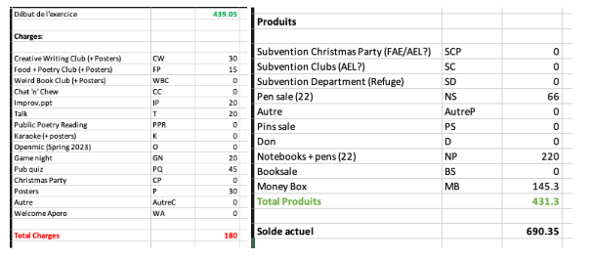
There were not a lot of changes from the budget projection, given that there are only a few clubs. We still have quite a bit of money, but Lisa says we'll ask for subsidies nevertheless.
      - 14 for (out of 14)
      - 0 against
      - 0 abstention(s)

- Previous events
  - Game Night (Katharina Schwarck)
For feedback on this event, Katharina sent a text message to Leah because they were absent. There were far fewer people compared to previous game nights. It took place on 20th march at the CAP, and was co-organised alongside several associations (Helios, Paragone, No Cap, Stu.de).

  - Team Building (Leah Didisheim)
It was at Leah's mom's place. It took place on April 4th, we had our traditional potluck dinner. It was really nice. We thank Leah and her mom for allowing us to host the event at their place.

  - Pub Quiz (Katerina Lo Presti and Malory Goy)
It took place at Qwertz on April 30th. Twelve to fifteen people attended over the evening. Katerina said that they improvised a karaoke night after the Pub Quiz finished, and that it was fun. Andreia adds that, out of all the venues we have held our Pub Quiz at, it was surely the best one so far. The staff at Qwertz were great, they didn't charge us for the space, and we had a really nice space for the event.

  - Improv.ppt (Lina Rosinander and Cindy Zhang)
This took place on May 7th. We had more people turn up than powerpoints received, so Lina mentioned that we recycled powerpoints from the previous years. Some people presented more than once, and we ended up doing duo presentations as well. It was fun. Lina points out that we could encourage people to send in a powerpoint if they show up so we avoid re-using older slides in the future.

  - Welcome Apéro (Leah Didisheim and Andreia Abreu Ramigio)
It took place on October 1st. We couldn't book the usual space in front of the ANT1129, even though we made sure to book it early - there apparently was an exhibit in that spot. Leah says that the Survey class had changed from Anthropole to Amphimax, and that they noticed it shortly before the apéro's starting time, so there were worries that students (especially first years) wouldn't come back to Anthropole for the apéro – but some did indeed show up. In addition, two teachers were there as well. It went well, and we didn't spend a lot of money because we had a lot of alcohol left from last year's Christmas Party. Leah and Andreia agree that sending the invitation to the English department's staff, as well as to students, was a good idea.

- Clubs
  - Creative Writing Club (Current organizers: Leah Didisheim, Andreia Abreu Remigio)
Spring organisers are Leah and Andreia; Autumn organisers are Leah and Martina. The first session last week went well. The attendance was good; we will see if it stays that way throughout the semester.

  - Food + Poetry Club (Current organizers: Katerina Lo Presti)
Katerina steps down from the club’s organisation because of time issues. Lisa says that she's interested in taking over, and that the club can start late this semester. Katerina and Lisa will talk together about F+P.

  - Chat ‘n’ Chew
It is still inactive.

- Money-Making
  - Book sale
Last semester's book sale went well, Leah suggests that we should keep doing it at least once a year.
  - Notebook sale
We still have notebooks available.
  - Pen sale
Pens are also still available.

Nothing else is organised for now in terms of money-making. Lisa points out that there is currently no pressure for the association money-wise, especially if we can have subsidies. Leah suggests that we keep bringing the merch to events so people can check it out and eventually buy some.

- Upcoming events
  - Talk (Leah Didisheim and Amélie Dauban)
This talk started being organised last semester. It will take place on Tuesday 28.10, posters are already up around the Anthropole. Matthew Scully will talk about the politics of desire in contemporary American literature. It will last around 45-60 minutes. For next talk, a post-doc, Patrizia Zanella, came to SCOPE at the Welcome Apéro to say that they would be interested in giving a talk. Cindy and Laura will reach out to them to co-organise this event.

  - Game night
It will take place on Wednesday 19.11. The associations that we co-organised this event with before (Helios, Paragone, No Cap, Stu.de) reached out through Whatsapp to know if SCOPE would be interested to join. Leah says we will ask the groupchat to see if anyone is interested, otherwise we'll pass this time.

  - Pub Quiz
Malory is interested in taking care of the quiz. Leah mentions that there's a newbie, Alicia B., who reached out by email to state their interest but couldn't attend the AG – perhaps they will co-organise it with Malory.

  - Christmas Party (10.12)
It will take place on Wednesday 10.12. Leah, Andreia and Lisa will organise this. Leah says that she has emailed our usual DJ, Digby, twice already, but we don't have a reply yet. It will be held at the Refuge du Censuy on the 10th December.

  - Improv.ppt.
William and Lina will co-organise this.

  - Others?
Katerina mentions collaborating with Books Books Books, maybe for a reading evening during next semester. Lisa would be interested in organising such a potential event alongside Katerina.

- Team Building
Leah introduces the event. We will surely have a potluck dinner. The organiser is responsible for the time and place; Leah will be organising and hosting SCOPE members for team building.

- Budget & Accounting
  - Autumn 2025 Budget Projection
Lisa presents the planned budget. There is money for all clubs and activities. If people need more money, they have to reach out to Lisa before spending it, take a picture of the receipt, and send it to her, so that it can be reimbursed. Leah mentions that we should ask for subsidies.
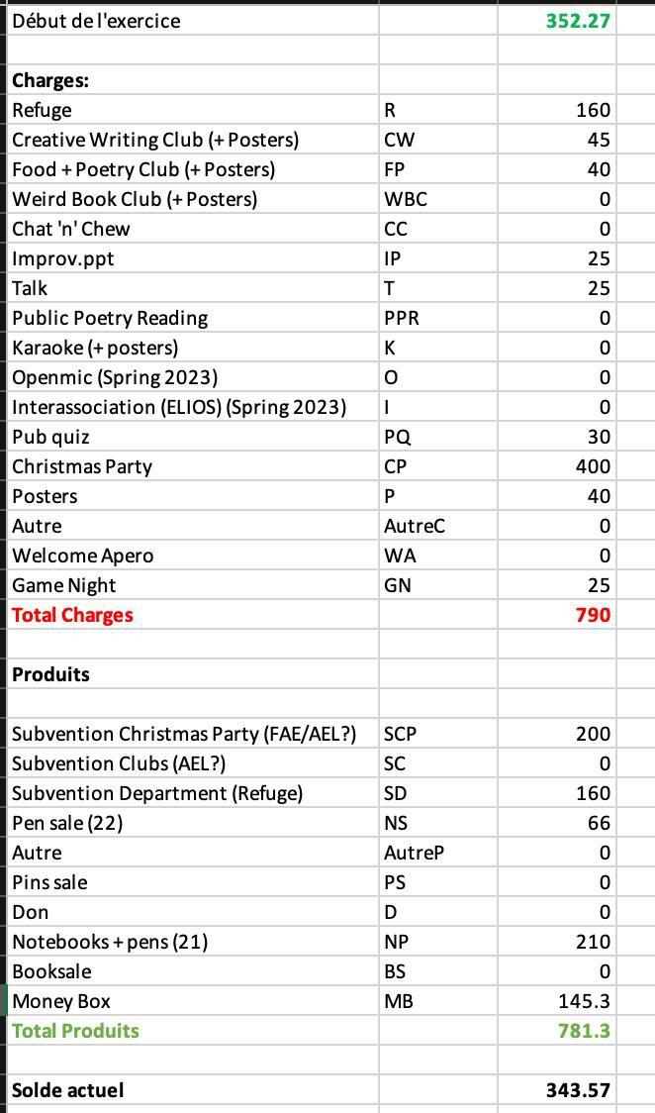

    - 14 for (out of 14)
    - 0 against
    - 0 abstention(s)

- Other

Leah starts off by reading Katharina's text to the members of SCOPE.

  - Statuts update
Leah mentions that she changed the statuts for them to be more inclusive and aesthetically pleasing. The statuts of the association will therefore be reconducted, a process that associations have to go through every few years. Leah shows the assembly that she created a Google drive folder with instructions on how to do the statuts reconduction for future SCOPE members.

  - AI Focus Group update
For the newbies and members who weren't made aware of this focus group, Leah discusses its purpose: some classes, especially at the BA level, are now validated solely by in-class assignments, so that the teachers can be sure that AI was not used in such works. However, some BA students raised this issue with SCOPE, because they felt it would be difficult to arrive at the MA level and have to write a mémoire, when all throughout their BA studies, they might have never had an essay to work on at home. The AI focus group, consisting of several department members, alongside both BA and MA students of English here at UNIL, met up three times to talk about the pros and cons of in-class work compared to assignments to take home. Overall, it was impossible to find one unique solution that would please everyone; however, the focus group agreed that the best option would be to try to find a balance between having to do all essays in-class and having to write them at home, especially for BA students. It is worth noting that reflections around AI and its impact on essays and validations are conducted currently at faculty level, as expressed by Jennifer Thorburn during last semester's English department AG.

Leah closes the assembly at 13:47.

“Current members” is used for internal purposes to refer to individuals who either are or have been students in UNIL’s English Department who wish to participate more closely in the organization of SCOPE events and activities and who the committee communicates with informally. This practice does not seek to come into conflict with Article 3 of SCOPE's statuts, which states that all students regularly enrolled in courses taught by the English section are members. c.F SCOPE’s statuts: 3.1 Est membre d’office, tout-e étudiant-e régulièrement inscrit-e à des enseignements dispensés par la section d’Anglais.

