**General Assembly SCOPE – Friday 10th of March, 2023, 4.15pm, ANT3174**

**Current members[1]:**

Alice Bovey, Andreia Abreu Remigio, Arthur Margot (President), Beatrice Muntean, Eloise Nuoffer, Emilie Badoux, Jessi Cardinaux (Treasurer), Guillaume Amstutz, Hakim Sahal, Isabelle Fasnacht, Joëlly Brütsch, Katharina Schwarck (Secretary), Leah Didisheim (Vice-President), Lisa Ziegert, Lucie Ortet, Manuel Ferrazzo, Martina Quadroni, Mathias Le Bailly, Laura Mottiez, Lex Rodriguez (Webmaster), Réka Gaál, Roxane Kokka, Sabine Lapin Weyermann, Salomé Streiff, Samuel Abbet, Tonia Ramogida, Veritsa Vuchkova, William Flores

OUT: Emilie Badoux

IN: Alicia Saner, Hannah Maxwell, Maxime Regamey

**Present:**

Alicia Saner, Arthur Margot (President), Beatrice Muntean, Emilie Badoux, Jessi Cardinaux (Treasurer), Hakim Sahal, Hannah Maxwell, Katharina Schwarck (Secretary), Leah Didisheim (Vice-President), Lisa Ziegert (arrived at 16:29 after the vote on the ODJ), Maxime Regamey, Lex Rodriguez (Webmaster), Réka Gaál, Roxane Kokka, Tonia Ramogida

**Absent:**

Alice Bovey, Andreia Abreu Remigio, Eloise Nuoffer, Guillaume Amstutz, Isabelle Fasnacht, Joëlly Brütsch, Lucie Ortet, Manuel Ferrazzo, Martina Quadroni, Mathias Le Bailly, Laura Mottiez, Sabine Lapin Weyermann, Salomé Streiff, Samuel Abbet, Veritsa Vuchkova, William Flores

1. **Welcome & Introductions**

The president welcomes the assembly. The members of the assembly introduce themselves.

1. **Accepting previous minutes and the current agenda**
   1. **PV**
      1. 11 for (out of 13)
      2. 0 against
      3. 2 abstention(s)
   2. **ODJ**
      1. 13 for (out of 13)
      2. 0 against
      3. 0 abstention(s)
2. **Request to remain in SCOPE**
3. **Arthur Margot’s request**

No objections are raised and therefore Arthur Margot will remain in SCOPE.

1. **Elections**
   1. **President**
      1. Current: Arthur Margot   
         (will **not** be going for re-election)
      2. Candidate(s): **Leah Didisheim**
         1. 12 for (out of 14)
         2. 0 against
         3. 2 abstention(s)
   2. **Vice-president**
      1. Current: Leah Didisheim  
         (will **not** be going for re-election)
      2. Candidate(s): **Hakim Sahal**
         1. 12 for (out of 14)
         2. 0 against
         3. 2 abstention(s)
   3. **Secretary**
      1. Current: **Katharina Schwarck**  
         (going for re-election)
         1. 13 for (out of 14)
         2. 0 against
         3. 1 abstention(s)
   4. **Webmaster**
      1. Current: **Lex Rodriguez**  
         (going for re-election)
         1. 11 for (out of 14)
         2. 0 against
         3. 3 abstention(s)
   5. **Treasurer**
      1. Current: Jessi Cardinaux  
         (will **not** going for re-election)
      2. Candidate(s): **Lisa Ziegert**
         1. 12 for (out of 14)
         2. 0 against
         3. 2 abstention(s)
2. **Budget & Accounting: Autumn 2022 Account Summary**

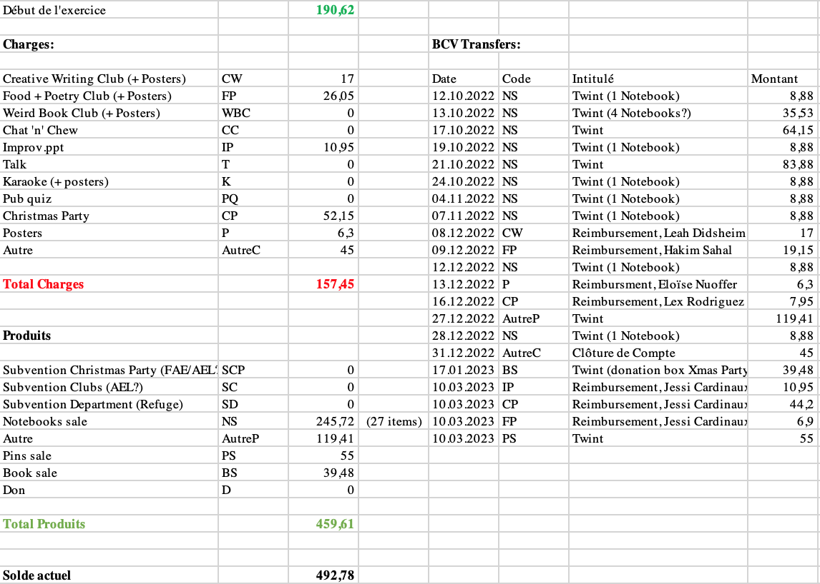

Jessi presents the expenses and the product of the Autumn 2022 semester. The Christmas party ended up costing us much less than expected and we were able to make money with sales (notebooks, pins, other books, donations) throughout the Autumn 2022 semester.

The notebooks worked amazingly. The pins did not sell as well as expected but it still got us some money. No subsidies were received.

The money spent for the clubs last semester is not representative of what we usually spend - last semester’s expenses were far below our average.

Subsidies can only be received if our accounts are empty enough. Our goal is nonetheless to start our semesters with as much money as possible. Arthur highlights that it is still interesting to organize events that are free, such as the Dovecote Visit in Spring 2022. The Pub Quiz (March 2nd 2023) is not accounted for in this representation.

1. **Account**
   1. 14 for (out of 14)
   2. 0 against
   3. 0 abstention(s)
2. **Previous events**
   1. **Notebook sale** (Organizer: Katharina)

Katharina says that the notebooks were a success. We were able to sell 65 out of 100 notebooks in the Autumn semester, namely during Chat ‘n’ Chew sessions, our Welcome Apéro on September 28th 2022 and during our Christmas Party on December 22nd 2022. We sold them at 9 CHF a piece and received many donations in the process, too. They were advertised in emails and on instagram. We will keep selling them to those interested throughout Spring 2023 and increase our advertising efforts in Autumn 2023 when there are new students and another Welcome Apéro and another Christmas Party.

* 1. **Improv.ppt** (Organizers: Réka, William)

Réka says that the event went well. It was very fun. It would have been fun to grab a beer afterwards but that did not happen. The organization was smooth and the powerpoints were fun. There are enough powerpoints for next time. The publicity around it was very good and many people outside SCOPE came.

* 1. **Team Building** (Organizer: Lex)

Lex says that Team Building was cool. It happened at their house. There was a little bit of a misunderstanding in the organization at the beginning and not very many people attended, perhaps because of that. It was still enjoyable to bond outside of other SCOPE activities.

* 1. **Karaoke night** (Organizers: Hakim, Roxane)

The organizers say that this did not go very well. People had fun but the organization was not perfect: we were ripped off by the place at which we organized it and it was not cooperative and not honest. The food was not good. We still managed to pull through and asked for financial help to reimburse the debt that was created, which worked out well. Hakim and Roxane in particular donated towards reimbursing this debt. Hakim thanks all the SCOPE members who were there and supported the organizers during the event. Roxane and Hakim handled the situation very well.

Hakim highlights that the idea of the event is great but it might not be a great idea to do it outside of university premises for reasons of price and options of privatization.

Lex highlights to always check reviews on places we may book. Jessi says that this one bad experience should not keep us from organizing more Karaoke nights. As long as the required material is present, this event can be organized in many different places.

* 1. **Christmas party** (Organizers: Leah, Lex, Katharina)

Leah says that we ended up spending much less money on this event than in other years because the English Department helped us a lot, for which we are extremely grateful. This year we did not have our usual DJ Digby. He usually provides the sound material and some lights, too. Lex contacted ESN who lent us their speakers for free and we are very grateful to them. We created a collaborative playlist. We did however not have Digby’s usual party lights. Enough people helped us in the kitchen, with setting up and tidying up, which was great and we thank them. Agnieszka went shopping with and for us and helped us with many many things. She came to the Christmas party too and advertises for us. We are extremely grateful to her. Several other staff members came.

* 1. **Pub quiz** (Organizers: Lisa, Sabine)

Lisa says that it went pretty well. The organization, however, was a bit complicated. In Autumn 2022 we were not able to find a venue but we did find one for the beginning of the Spring 2023 semester. The event took place at *La Datcha*, like in Autumn 2021. Lex says that *La Datcha* is really cool. We get to hold our Pub Quiz there for free and it’s quiet enough. We don’t always have to do it there but it’s a good place.

* 1. **Public Poetry Reading** (Organizers: Arthur, Jessi, Hakim)

This did not happen in the previous semester. It was pushed back to this coming semester.

* 1. **Game Night with Helios** (Organizer: Katharina)

This event did not happen. We might reconsider this for this coming semester. Jessi says that the AEL wants to organize more interassociative events, so we might expect more of this in the future.

1. **Clubs**
   1. **Creative Writing Club** (Current organizers: Katharina, Leah)

Leah says that it went well. Leah and Katharina work well together. We had four sessions last semester, always on Tuesdays. The audience was quite stable. It was nice.

* 1. **Food + Poetry Club** (Current organizers: Hakim, Jessi)

Hakim says it always goes well. There’s a very stable audience. However, towards the end of the Autumn 2022 semester there were not very many people anymore. Hakim and Jessi say that they have some work flow issues and Jessi will step down from the organization henceforth. This club also took place four times last semester, always on Tuesdays.

* 1. **Weird Book Club** (Current organizer: Beatrice)

Beatrice says that it went well. The audience is not as big as the one for F+P, but still stable. There were just some issues with accessing the rooms in Vortex. This club also took place on Tuesdays in Autumn 2022, alternating with the other two above-mentioned clubs.

Salomé used to help Beatrice. Beatrice asks Hakim for a cooperation on helping each other out on their clubs, as they shall be alternating every Wednesday of the Spring 2023 semester.

* 1. **Chat ‘n’ Chew** (Current organizers: Katharina, Leah)

This event always goes strong. We always have regulars. Not many new people come. It’s always fun. We chill and talk.

1. **Upcoming events**
   1. **Talk** (Organizer: **Leah**)

The next Talk will take place on March 21st: Rachel Falconer will talk about J.R.R. Tolkien’s environmental vision. Everything is ready for this event. During the last AG we decided to spread out our events more and to organize Talks more towards the beginning of the semester so more people can attend outside the end-of-semester-stress.

At this point, Leah highlights that it is always okay to step down from organizing an event. The earlier the organizer(s) say(s) this, the better, so we can find a solution. Nobody will ever be judged for stepping down from any type of organization of commitment.

The next Talk would take place at the beginning of the Autumn semester. We could ask PHD students. **Katharina** will organize this and we will brainstorm and decide on who to invite together.

* 1. **Public Poetry Reading**

Jessi says that the Grange is booked out and we need to plan this event roughly 6 months before we want to do it. However, we could use any comfortable space that is suitable for this type of event. For now, this event will be postponed. **Jessi** and/or **Hakim** will probably organize this.

* 1. **Game Night**

We could do our own game night or co-organise this with an association. **Katharina** and **Roxane** will look into this.

* 1. **Improv.ppt**

**Arthur** and **Lex** would like to organize this. This will probably take place this semester.

* 1. **Pub Quiz**

**Lisa** and **Maxime** want to organize a Pub Quiz at the beginning of the Autumn 2023 semester. Most often bars are not available for this on Fridays, which is why this type of event most often happens on Thursdays. Leah highlights that scheduling questions can be discussed outside of the AG to save time during the AG.

* 1. **Bat Walk**

Tonia has an idea for a Bat Walk. There is a professor who could maybe guide us through the university’s forest, teaching us about bats. **Tonia** will look into this.

1. **Money-Making**
   1. **Book sale**

Sometimes this can be quite successful. We have a lot of fiction books in our locker. Sam still has many more books at home, Emilie will donate some of them to us, too. Katharina suggests having a book sale at the beginning of Autumn 2023 semester. We need to make sure our communication with AEL is clear as they also have a book sale at the beginning of the Autumn semester, so as to not create any conflicts of interest. **Katharina** will be in charge of the organization.

* 1. **Notebook sale**

We will keep selling these throughout the semester if people are interested and we will put more effort in selling them again in the Autumn semester during our events then.

* 1. **Pens**

Hakim has the idea of potentially selling pens. The assembly is invited to research this if they are interested in this.

1. **Team Building**

**Roxane** wants to organize Team Building. It will take place at her house. **Beatrice** will help her out. Details can be discussed later. Because of the availability of the location, this will take place on a Friday or a Saturday.

1. **Budget & Accounting: Spring 2023 Budget Projection**

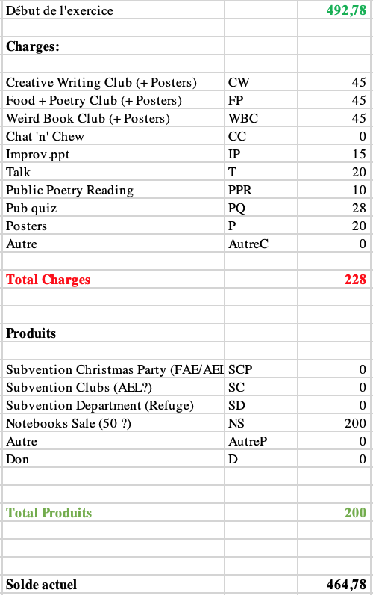

Jessi says that if we are to ask for subsidy, we need to have emptier accounts. The Pub Quiz in this representation is the only real sum spent: everything else is a projection. Arthur highlights that we need to keep receipts to be reimbursed. Leah mentions that expenses need to be approved by the treasurer before they are spent.

1. **Budget**
   1. 12 for (out of 14)
   2. 0 against
   3. 2 abstention(s)
2. **Other**
   1. **Fréquence Banane**

Fréquence Banane invited us to be interviewed about our association this March. An email needs to be sent to them ASAP to confirm us going and when. **Roxane** and **Leah** will organize this.

* 1. **Pins**

We have a few pins left. They cost 3 CHF a piece.

* 1. **Community and atmosphere**

Tonia appreciates SCOPE’s sense of community. The assembly appreciates this comment.

* 1. **Arthur’s words**

Arthur thanks the assembly for the time spent together up to now. SCOPE was a highlight of his university life and he is very happy to have joined SCOPE and happy to see that SCOPE keeps living and growing.

**The AG is closed at 17:53.**

1. “Current members” is used for internal purposes to refer to individuals who either are or have been students in UNIL’s English Department who wish to participate more closely in the organization of SCOPE events and activities and who the committee communicates with informally. This practice does not seek to come into conflict with Article 3 of SCOPE's *statuts*, which states that all students regularly enrolled in courses taught by the English section are members.

   c.F SCOPE’s *statuts*: 3.1 Est membre d’office, tout-e étudiant-e régulièrement inscrit-e à des enseignements dispensés par la section d’Anglais.