General Assembly SCOPE – 7th of October, 2022, 16h15. ANT3032.

Current members*:
Alice Bovey, Andreia Abreu Remigio, Angela Alberti, Arthur Margot (President), Beatrice Muntean, Emilie Badoux, Gislain Cardinaux, Guillaume Amstutz, Hakim Sahal, Isabelle Fasnacht, Joëlly Brütsch, Katharina Schwarck (Secretary), Leah Didisheim (Vice-President), Lucie Ortet, Manuel Ferrazzo, Marie Anex (Treasurer), Martina Quadroni, Mathias Le Bailly, Muriel Salamin, Laura Mottiez, Lex Rodriguez (Webmaster), Réka Gaál, Roxane Kokka, Sabine Lapin Weyermann, Samuel Abbet, Sorcha Walsh, Tonia Ramogida, William Flores

OUT: Angela Alberti, Marie Anex, Muriel Salamin, Sorcha Walsh
IN: Eloise Nuoffer, Lisa Ziegert, Salomé Streiff, Veritsa Vuchkova

Present:
Alice Bovey (arrived at 16:22, during introductions, left at 16:40, before vote for secretary), Arthur Margot (President), Beatrice Muntean (arrived at 16:29 for the vote on the ODJ, left at 17:36, after discussing clubs), Eloïse Nuoffer, Jessi Cardinaux, Guillaume Amstutz, Hakim Sahal (left at 18:42, during the discussion about budgeting), Isabelle Fasnacht (arrived at 16:40, before voting for the secretary, left at 18:40, during the discussion about budgeting), Katharina Schwarck (Secretary), Leah Didisheim (Vice-President), Lisa Ziegert (left at 18:22 during the discussion about budgeting), Marie Anex (Treasurer), Lex Rodriguez (Webmaster, left at 18:25 during the discussion about budgeting), Réka Gaál, Roxane Kokka (arrived at 16:32, before elections), Salomé Streiff (arrived at 17:20, while talking about past Team-Building), Sorcha Walsh (left at 17:16, before talking about the pub quiz), Tonia Ramogida (left at 18:42, during the discussion about budgeting), Verista Vuchkova (left at 17:36, after talking about clubs), William Flores
Absent:
Andreia Abreu Remigio, Angela Alberti, Emilie Badoux, Joëlly Brütsch, Lucie Ortet, Manuel Ferrazzo, Martina Quadroni, Mathias Le Bailly, Muriel Salamin, Laura Mottiez, Sabine Lapin Weyermann, Samuel Abbet

- Welcome & Introductions
The president Arthur reads messages from Andreia and Muriel who are absent today. Andreia greets the assembly and says that she misses us. Muriel, who is leaving the association after this AG, says how much she has appreciated the association, how many amazing friends and memories she has made. She says that she will miss us and to keep up the good work.
- Accepting previous minutes and the current agenda
  - PV
    - 14 for (out of 15)
    - 0 against
    - 1 abstention
  - ODJ
    - All for (out of 16)
    - 0 against
    - 0 abstentions
- Requests to remain in SCOPE
- Katharina Schwarck’s request
  - All for (out of 16)
  - 0 against
  - 0 abstentions
- Mathias Le Bailly’s request
  - 14 for (out of 16)
  - 0 against
  - 2 abstentions
Before elections, Sorcha notes that, when it is possible and the assembly has enough candidates for committee positions and the organization of events who are enrolled in the English department, it is important to have members who are enrolled in the English department so that the association represents the English Department’s students well.
- Elections
  - President
    - Current: Arthur Margot
(going for re-election)
      - 16 for (out of 17)
      - 0 against
      - 1 abstention
  - Vice-president
    - Current: Leah Didisheim
(going for re-election)
      - 16 for (out of 17)
      - 0 against
      - 1 abstention
  - Secretary
    - Current: Katharina Schwarck
(going for re-election)
As the candidate is no longer enrolled in the English department since graduating in September 2022, the assembly suggests including the comment that was made before elections by changing the voting system to reflect the assembly’s opinions on this matter better. The suggestion made is that the candidate needs more votes for than against and abstentions combined. If this is not accepted, then the candidate only needs more votes for than against, as during a usual election. This idea for an extraordinary voting modality is voted on.
- Voting on the modality according to which the candidate needs more votes for than against and abstentions combined. If this is not accepted, then the candidate only needs more votes for than against.
  - 13 for (out of 17)
  - 1 against
  - 3 abstentions
The first voting modality is accepted. The candidate therefore needs more votes for than against and abstentions combined.
Election:
      - 15 for (out of 17)
      - 0 against
      - 2 abstentions
  - Webmaster (this election concerns the usual voting modality again)
    - Current: Lex Rodriguez
(going for re-election)
      - 16 for (out of 17)
      - 0 against
      - 1 abstention
  - Treasurer
    - Current: Marie Anex
(will not be going for re-election)
    - Candidate(s): Jessi Cardinaux
      - 15 for (out of 17)
      - 0 against
      - 2 abstentions
- Budget & Accounting: Spring 2022 Account Summary
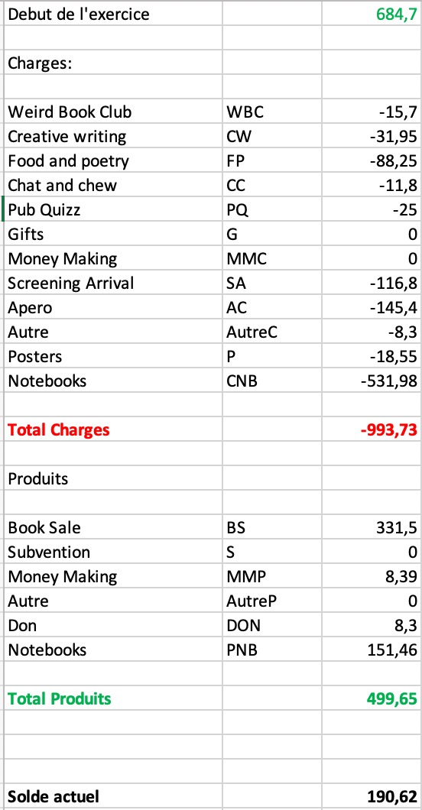
The budget that was planned for the clubs was mainly respected. We got the money through subsidies. F+P spent a little more than planned but the additional expenses were reimbursed without any problems.
The shown table represents the expenses between the last AG and now. This means that events that occur early in the semester but before the AG already appear in the forms, such as the back-to-uni apéro.
Notebooks have been purchased but not yet completely sold so the product does not yet appear on our account. They appear as “Notebooks” and not as “Money-Making Event” as they are for this coming semester’s money making and not last semester’s.
Marie reminds the assembly of the fact that when one is paid in cash, they need to go to the bank and put the cash onto our bank account. When this happens, the member going to the bank needs to say the name of the association as we do not have a bank card.
We did not ask for any subsidy in the past semester from either FAE or AEL and we currently have 190,62 CHF on our account.
Sorcha raises the idea of potentially presenting our budget and accounting over one year. If this seems relevant in the future, it will be rediscussed.
- Account
  - 16 for (out of 17)
  - 0 against
  - 1 abstention
- Previous events
  - Saint Patrick’s Day Party (organizer(s): Jessi)
According to Jessi, this event went great. We went to McCarthy's pub, staff members showed up and people had a good time. This event ended up taking a different shape than planned. Marie highlights that it is important to notify the treasurer of event changes to adapt the budget properly in order for potential left over money to be able to be used for something else.
  - Arrival Screening (organizer(s): Sorcha)
Sorcha says that this event went extremely well. This event was interassociative with ciné-club and AEL. It consisted of a screening of the movie Arrival and then a round-table including stuff members of the Cinema, English and Linguistics department respectively. Thanks to fundraising, we were able to make this event free and we appreciate that. The turn-out was great and Ciné-club members as well as the speakers expressed their appreciation for the event.
  - Improv.ppt (organizer(s): Beatrice, Roxane)
This event happened at Easter. It went well. Some powerpoints were however too long so not all were used. Roxane suggests having no more than 7 slides or they will not be used. Beatrice suggests having a time limit on the improvisations. Sorcha notes that this is not the first time that these sorts of comments have come up and that we really need to insist on shortening powerpoints and improvisations.
  - Book Sale (organizer(s): Laura, Marie)
Marie says that it went well and she thanks all the people who helped out. The point of this book sale was to make money, which worked well. We probably need to have a money-making event about every year. Marie says that it is important to keep in mind that most events cost money and that we probably should have more income than just subsidies.
  - Dovecote visit (organizer(s): Tonia)
Tonia says that she really appreciated both organisizing this event and attending. It was free for both SCOPE members and other participants and the building with the dovecote, the St. François church, . Unfortunately, is easily accessible. Unfortunately, the dovecote is not accessible to people with reduced mobility. 15 people participated, including Gérard, who led us through the dovecote and one staff member. Gérard began the visit in English and then, as he was more comfortable in French and everybody understood French, he switched to French.
x. At this point (17:14) Sorcha, who needs to leave before the end of the AG, shares her goodbyes. She is really thankful to SCOPE and says that it has had a great impact on her life and her studies. She actively thanks the members of the assembly and to past members.
  - Pub quiz (organizer(s): Andreia, Roxane)
Andreia and Roxane organized this. Andreia gives the following feedback: It is good to look for and book the venue really early. She preferred La Datcha over our last venue, the Tacos Bar, but La Datcha was completely booked. The Tacos Bar was fine but a bit too dark and noisy, and other customers had to go through our reserved room/spot to go to the toilet which was annoying. She adds that two organizers are more than enough. Further, it is good to try and book a date when nothing too major is going on. During our last pub quiz, there was Balelek the same night and many people told her they couldn't come because they already had tickets for that. Maybe we can consider making the Pub Quiz themed? She feels it could be fun to change questions up. Regardless of theme, she thinks that we should keep categories. It's better for doing rounds, taking breaks for drinks, counting points, etc. Not all categories have to be timed though
Roxane agrees with the point on the place where this event happened. She also agrees that two organizers are enough. Roxane got feedback from participants who suggested mixing categories so people don’t spend too much time on one category that they really appreciate or one that they don’t.
  - Team Building (organizer(s): Angela, Jessi, Leah)
This event happened at the lake, outside, in summer. Leah says that it went well and that one organizer instead of three would have been enough.
  - Summer Apéro
This event did not occur even though it was budgeted. Arthur reminds the assembly of the fact that organizers need to be transparent on events not happening to make budgeting easier. He underlines that nobody holds it against organizers if they cannot organize an event. The sooner an organizer speaks up, the better, and there is no shame in communicating not being able to organize anything.
  - Talk
No talk happened last semester.
  - Back to School Apéro (organizer(s): Katharina, Leah)
It went well even though less people showed up than last year. Leah says that some people said they would come and help out but they didn’t and for future events, communication on this is appreciated. We did have enough people in the end, so it went well. Salomé says that another apéro was happening at the same time around the same place. We should maybe look into this so there are no misunderstandings for people coming. Lex reminds the assembly that SCOPE needs a corkscrew.
Roxane adds that SCOPE was represented at the welcoming day on Friday before the rentrée. It went well and there are some leftover posters in the locker for people to take if they want.
- Clubs
  - Creative Writing Club (organizer(s): Katharina, Leah)
Last semester the club happened every two weeks on Monday. There was not a big audience so we asked for feedback on that. We have changed the day and are taking the feedback into account. Roxane appreciates that the prompts change every week.
  - Food + Poetry Club
    - Team (organizer(s): Arthur*, Hakim, Jessi)
*Arthur is no longer an organizer of the club. Hakim and Jessi are still on the team. Hakim says that the club is working really well. There were slightly fewer people during the first session of this semester and last semester as there were during Autumn 2021. The club is still going well and started well too. Marie says that it’s important to stick to the planned budget, no matter the size of the audience.
Hakim says the new club schedule that was decided by the club organizers for the Autumn 2022 semester (having WBC, F+P and CWC alternate every three weeks on Tuesdays) should be discussed at the AG. This point will be discussed in upcoming events.
  - Chat ‘n’ Chew (organizer(s): Arthur, Katharina, Leah)
Katharina says that she really appreciates the club. There have been fewer people overall and fewer new people than last year but the show-up is still consistent and it is a great moment to meet with people.
  - Weird Book Club (organizer(s): Beatrice and, starting now, Salomé)
Beatrice says that last semester, not as many people as she’d hoped came. Now the schedule is different and the club has a better room so it should work better this semester. The first session of this semester went great. She is looking for a co-organiser. Salomé will help her out.
- Upcoming events
Arthur would really like to shorten this AG by simply deciding who will organize events. Advice and ideas will be given via whatsapp or in real life after the AG. Lex mentions that descriptions of the events are still relevant so short descriptions will be given.
  - Christmas Party (organizer(s): Katharina, Leah, Lex)
The Christmas party occurs every December in the last or second last week of the semester in the Refuge de Censuy. The date has already been booked by staff member Agnieszka Soltysik Monnet for the 22nd of December 2022. Arthur recommends having only three organizers for this event. Marie agrees with this number and says that it is easier. She also reminds the assembly that a car is needed to bring material to the place of the party. One or several member(s) of the association will have to provide 500 CHF as a deposit for the day of the party. Jessi says that it is great if other members help out for preparation and/or clean up. The organizers usually send out a doodle to organize people to help out. Nothing has ever happened that made SCOPE lose the deposit. If that ever occurs, SCOPE will of course reimburse the person/people who gave the deposit. Because of this considerable amount, all organizers need to be aware of all the responsibilities, of what to clean, what to take care of, so everything goes well. Leah, Lex and Katharina will organize this event. If an organizer cannot do the work, they should ask for a substitute as soon as they can.
  - Improv.ppt (organizer(s): Réka, William)
This is an evening during which we do quick-fire improvisations on powerpoint presentations that the improvisers have never seen before. William and Réka will organize this event.
  - Talk (organizer(s): Leah)
For this event we invite one staff member. We raise the idea of having the talk at the beginning of the semester instead of at the end, as it has usually happened. The assembly accepts this idea. A talk will be organized this semester with the goal of taking place at the beginning of the spring 2023 semester. Leah will ask Rachel Falconer if she can give a talk. If Rachel Falconer cannot give the talk, someone else will be asked.
  - Pub quiz (organizer(s): Lisa, Sabine)
Lisa and Sabine want to organize this event.
  - Public Poetry Reading (organizer(s): Arthur, Jessi, Hakim)
This idea came up during F+P sessions. This event could include an open-mic session in a pub or elsewhere where people read out poetry. It is already being organized by Jessi, Hakim and Arthur. Budgeting for this was not yet discussed. For the budget, Marie will include an approximate amount.
  - Other
Hakim and Roxane want to organize a karaoke night. The budget would only include the price for some posters.
Lex has an idea which would be an open-mic, not only including poetry but for any artistic/creative performance. They do not plan this for this autumn semester. They will be in charge of organizing something of this shape next semester. Roxane and Samuel express their interest in co-organising this. The budget would only include posters but in the spring 2023 semester.
On the association welcoming day before the rentrée, SCOPE had its stand next to HELIOS. HELIOS’s members approached Katharina as a SCOPE representative and mentioned an idea which would include an interassociative game night. Katharina will reach out to HELIOS to see what shape this idea could take more exactly, with potentially organizing such an event in a semester or two.
Lex asks a question about previous emails that SCOPE received. We will discuss how to best share emails with the group later.
Hakim reiterates that the club schedule changed (WBC, F+P and CWC alternating every three weeks on Tuesdays) and says that this decision maybe should have been discussed with more members than just club organizers. Leah says that it’s easier to leave this decision up to the organizers as the club schedule mainly depends on their availability and club experience in past semesters. Members mention that it may be problematic to have all clubs on the same day as it keeps potential audience members who cannot attend on Tuesdays from attending anything. Katharina responds that Tuesdays have shown as a quite popular day in the past and that the WBC and CWC day has changed from last semester anyway, which now allows different people to come, depending on their schedules. Arthur suggests creating a groupe de travail to work out a new format for the clubs. Hakim, Jessi, Roxane, and Guillaume decide to be part of the groupe de travail. Katharina notes that regardless of a groupe de travail, we will gather experience on how well this format works throughout the semester and that it might change next semester.
- Money-Making
Marie and Katharina thought that it would be nice to sell notebooks as a money-making event. We ordered 100 notebooks and have started selling them. Paying modalities include cash and TWINT. Marie notes that TWINT takes a percentage of roughly 1.3% when a payment happens through it. The notebooks are sold at 9 CHF.
We still have many books (fiction, textbooks) in our locker and Samuel got a lot of books recently too, which were a donation to SCOPE. Lex suggests having a book sale. To be able to ask for subsidies, Marie suggests only selling those books next semester (spring 2023). We will first focus on selling the notebooks. Depending on our notebook sales, we could sell wrapped books at a free price during the Christmas party, as we did last year. Eloïse mentions that she could donate books to SCOPE, too.
Jessi ordered 50 pins and that they are selling, also to be able to finance SCOPE. 35 pins have already been sold, which gives an income of 55 CHF for now. They are sold for 3 CHF a piece. Members of other associations have expressed their interest in the pins so we might order more soon and advertise them broadly.
- Team Building (organizer(s): Réka)
Leah suggests having Team Building close to the AG to include new members quickly. Réka will organize it and suggests having it at their house.
- Budget & Accounting: Autumn 2022 Budget Projection
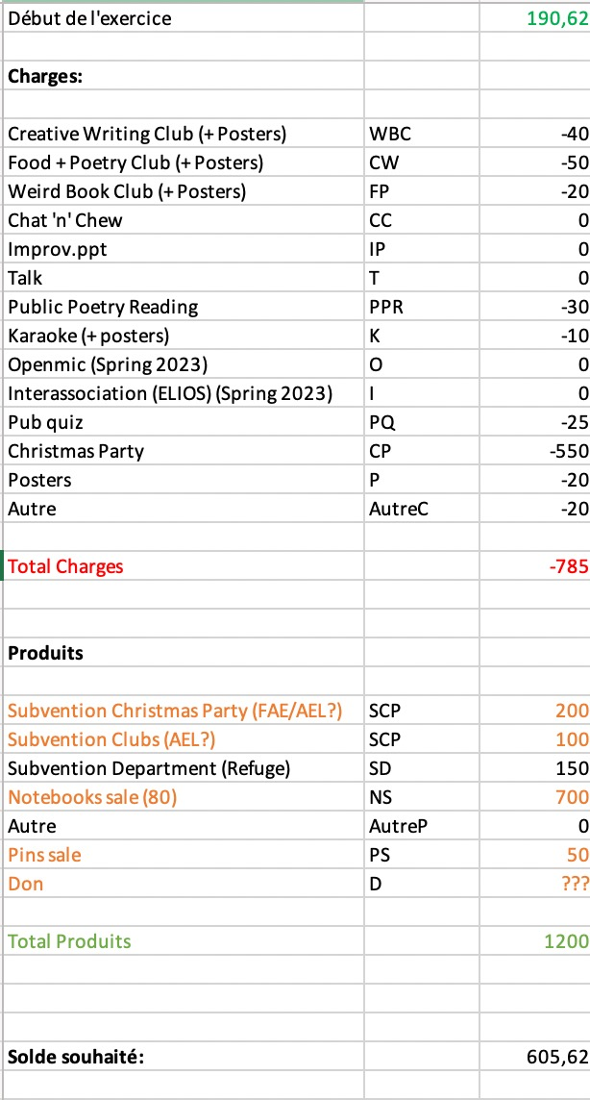
Posters are now more expensive. Katharina will try and order cheaper ones next time. Marie asks event and club organizers to respect the budget and discuss changes with the treasurer. Since our Christmas party is open to people outside of the English Department, we can ask the FAE for subsidy. Last time they gave us 200 CHF. Agnieszka, who booked the refuge for us, booked it for cheaper than last year, but we are yet to receive a confirmation and the exact price.
If we get a subsidy from FAE, we have to use it for the event we asked for. We will ask the AEL if they can give us 100 CHF to finance the clubs for one semester. Last year they gave us 200 CHF for the clubs for the whole year. It is okay to use money destined for one club for a different club.
Marie encourages us to sell the notebooks during all events and clubs when it is possible. Marie recommends selling all notebooks this semester because with that we would be able to show the FAE that we are trying to make money. Selling all notebooks this semester may not be realistic, which is why we’d need a subsidy. We could keep 30 notebooks aside for the Christmas party to sell them then.
When Marie asked for a subsidy for the Christmas party last year, her argument was that we needed a subsidy so we could start off the next semester with black numbers. For the Christmas party we need to make sure we respect FAE’s deadlines to ask for subsidy. This is similar for AEL. We need to ask for a subsidy on time.
- Budget
  - 8 for (out of 9)
  - 0 against
  - 1 abstention
- Other
Katharina and Lex will take care of advertising the notebooks. Notebooks can of course be sold to people outside of the English Department, if members want to do that.
Salomé mentions places that give away drinks and food for free. They ask for advertisements in exchange. Aligro also offers percentages off for certain associations, and Migros does something similar sometimes.
Katharina mentions the idea of cleaning the lake as a SCOPE event. Arthur extends this idea to cleaning the university for example as Team Building.
Marie says that organizers should take a picture of receipts with the date for easier organization and reimbursements.
The AG is closed at 18:51.

*“Current members” is used for internal purposes to refer to individuals who either are or have been students in UNIL’s English Department who wish to participate more closely in the organization of SCOPE events and activities and who the committee communicates with informally. This practice does not seek to come into conflict with Article 3 of SCOPE's statuts, which states that all students regularly enrolled in courses taught by the English section are members.

c.F SCOPE’s statuts: 3.1 Est membre d’office, tout-e étudiant-e régulièrement inscrit-e à des enseignements dispensés par la section d’Anglais.

